Alarm: ID 62: Loop Emergency Not Online
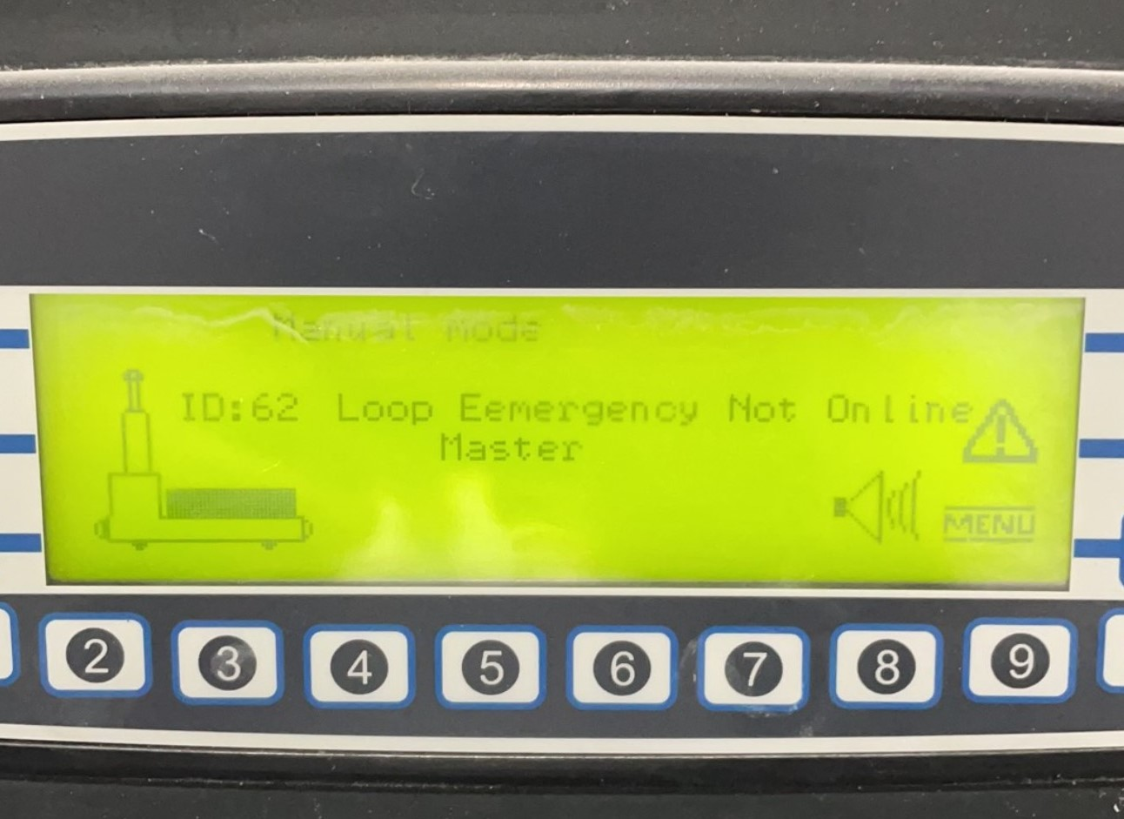
How To Fix:
This alarm occurs when there is a problem with the battery. Please consult a qualified AGV Technician.

